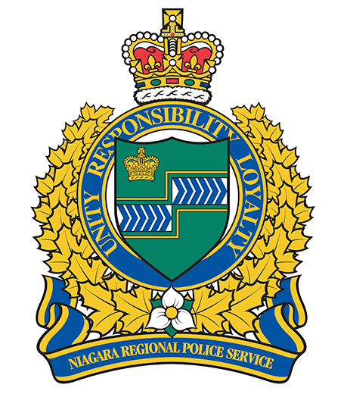
Niagara Regional POLICE SERVICE
Youth POLICE ACADEMY

REGISTRATION FORM

Please PRINT or TYPE - Registration forms must be filled out completely and legibly or application will not be processed.

Requirements to apply:

- Enrolled in Grade 7 and or 8
- Live in the Niagara Region
- Obtain parental/guardian consent
- Be able to attend all sessions. Students must attend every week in order to graduate; exceptions will only be made under exigent circumstances
- Waiver and PARQ if applicable

PERSONAL INFORMATION
Participant Surname:
Participant Given Name: Middle Name:
Gender: ☐ Male ☐Female ☐Other Date of Birth:(dd/mm/yy)
Address:
City: Province: Postal Code:
Telephone Number: Home: ( ) Business:( )
Guardian Surname:
Guardian Given Name: Middle Name:
E-mail:
Why do you wish to participate in the Youth Police Academy? (200 word essay)
How did you hear about the Youth Police Academy?

PLEASE READ CAREFULLY BEFORE SIGNING:

  - I hereby declare that the foregoing information is true and complete to the best of my knowledge. I understand that a false statement can disqualify me from participation in the Niagara Regional Police Youth Academy. I promise if I am selected, that I will not disclose any confidential information that I may become aware of.

  - I understand that if I am selected, the Niagara Regional Police Service is not responsible for any accident or injury that occurs to me or my property, unless caused by the negligence of the Niagara Regional Police Service.

  - I understand and agree that the Niagara Regional Police Service video unit, police personnel, and local media agencies may be in attendance at each session and that video coverage and still photographs will be taken at various times throughout the Academy and may be used by the Service and/or the media agencies.

  - The Niagara Regional Police Service reserves the right to sole discretion in the selection and the continued participation of Academy participants.

Dated Signature:

Please deliver or mail or e-mail to: Niagara Regional Police Service
Youth Police Academy
5700 Valley Way, Niagara Falls, ON. L2E 1X8
Attention: CORE Unit

e-mail: YouthAcademy@Niagarapolice.ca

Phone: 905-688-4111 Ext: 1025010

